**Assignment #2** (**100 points**): Due 11:59 pm, Sunday, March 27, 2022

1. In the false data injection (FDI) attack, assume that the normal measurement is $z=Hx+n$ and the attacked measurement is $z_{a}=z+a$. Assume that the weighted least square (WLS) solution is given by $\hat{x}={\left(H^{T}R^{-1}H\right)}^{-1}H^{T}R^{-1}z$ for the normal measurement $z$, and let ${\hat{x}}_{a}$ be the WLS solutionobtained from the attacked measurement $z_{a}$. Use your linear algebra knowledge to prove that the pre-attack residual $r=z-H\hat{x}$ is the same as the post-attack residual $r_{a}=z_{a}-H{\hat{x}}_{a}$ if $a=Hc$. (**20 points**)

#### Solution:

Given,

Pre-attack residual 𝐫 = 𝐳 − 𝐇𝐱̂

Attacked measurement is 𝐳𝐚 = 𝐳 + 𝐚

Normal measurement is 𝐳 = 𝐇𝐱 + 𝐧

and the Post-attack residual 𝐫𝐚 = 𝐳𝐚 − 𝐇𝐱̂𝐚**.**

= > 𝐳 + 𝐚 − 𝐇 [(𝐇𝐓𝐑−𝟏𝐇)−1𝐇𝐓𝐑−𝟏𝐳𝐚]

= > 𝐳 + 𝐚 − 𝐇 [(𝐇𝐓𝐑−𝟏𝐇)−1𝐇𝐓𝐑−𝟏(z + a)]

= > 𝐳 + 𝐚 − 𝐇 **[**(𝐇𝐓𝐑−𝟏𝐇)−1𝐇𝐓𝐑−𝟏𝐳 **+**(𝐇𝐓𝐑−𝟏𝐇)−1𝐇𝐓𝐑−𝟏 𝐚**]**

**= >** 𝐳 + 𝐚 − 𝐇 **[** 𝐱^ + (𝐇𝐓𝐑−𝟏𝐇)−1𝐇𝐓𝐑−𝟏 𝐚**]**

**= >** 𝐳 + 𝐚 − 𝐇 **(**𝐱^ + 𝐇−𝟏𝐚**)**

**= >** z + a − H (x̂ + )𝑎

𝐻

**= >** 𝐳 + 𝐚 − 𝐇 **(**𝐱^ + 𝐜**)**

**= >** 𝐳 − 𝐇𝐱^ + 𝐚 − 𝐇𝐜

**Since** 𝐚 = 𝐇𝐜 **= >** 𝐳 − 𝐇𝐱^ + 𝐚 − 𝐚

**= >**𝐳 − 𝐇𝐱^

Which implies **r=** 𝐫𝐚

### Hence it is proved that the pre-attack residual 𝐫 = 𝐳 − 𝐇𝐱^ is the same as the post-attack residual

𝐫𝐚 = 𝐳𝐚 − 𝐇𝐱^𝐚, if 𝐚 = 𝐇𝐜

1. A one-line diagram of a 3-bus power system is shown below. Assume that we have one meter installed on each line to measure the power flows. For bus 𝑖 and 𝑗 connected by a line, the power flow 𝑃𝑖𝑗, the reactance 𝑋𝑖𝑗, and voltage angles 𝜃𝑖, 𝜃𝑗 are considered to approximately follow the relation below when no noise is considered:

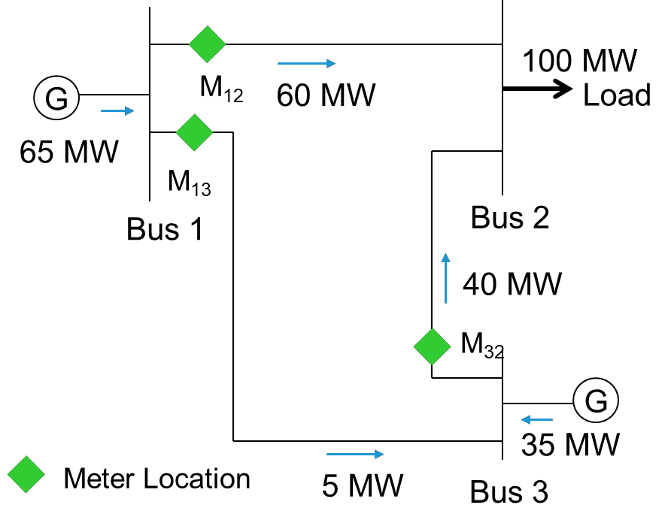𝑃𝑖𝑗 = (𝜃𝑖 − 𝜃𝑗)/𝑋𝑖𝑗

The line reactance has been measured in advance as:

𝑋12 = 0.50 𝑝. 𝑢.

𝑋13 = 0.10 𝑝. 𝑢.

𝑋32 = 0.25 𝑝. 𝑢.

The meter readings have been reported as:

$M$ 12 = 0.60 𝑝. 𝑢.

$M$ 13 = 0.05 𝑝. 𝑢.

$M$ 32 = 0.40 𝑝. 𝑢.

Solve the questions below. (**80 points**)

1. Assume that $θ_{1}=0$ is the reference angle. Using different pairs of meter readings, find the values below:
   1. $θ_{2}$, $θ_{3}$ and $P_{12}$, using only the values of $M_{13}$, $M_{32}$ and the reactance $X$.
   2. $θ_{2}$, $θ_{3}$ and $P_{13}$, using only the values of $M_{12}$, $M_{32}$ and the reactance $X$.
   3. $θ_{2}$, $θ_{3}$ and $P_{32}$, using only the values of $M_{12}$, $M_{13}$ and the reactance $X$.

#### Solution:

Given,

Line reactance has been measured in advance are:

𝑋12 = 0.50 𝑝. 𝑢.

𝑋13 = 0.10 𝑝. 𝑢.

𝑋32 = 0.25 𝑝. 𝑢.

Meter readings are:

M12 = 0.60 𝑝. 𝑢.

M13 = 0.05 𝑝. 𝑢.

M32 = 0.40 𝑝. 𝑢.

𝑃𝑖𝑗 = (𝜃𝑖 − 𝜃𝑗)/𝑋𝑖𝑗

M12 = ( 𝜃1 - 𝜃2)/ 𝑋12

0.60 = ( 0 - 𝜃2 ) / 0.50

= >> 0.300=0 - 𝜃2

= >> 𝜃2 = - 0.3

M13 = ( 𝜃1 − 𝜃3) / 𝑋13

0.05 = ( 0 - 𝜃3 ) / 0.10

= >> 0.005 = 0 - 𝜃3

= >> 𝜃3 = - 0.005

Similarly,

𝑃32 = (𝜃3- 𝜃2)/ 𝑋32

= >> ( - 0.005 + 0.300 ) /0.25

**P32 = >> 1.18 𝑝. 𝑢.**

Given,

M12 = ( 𝜃1 - 𝜃2)/ 𝑋12

0.60 = (0-𝜃2)/0.50

= > 0.3=0- 𝜃2

= > 𝜃2 =-0.3

M32= (𝜃3- 𝜃2)/ 𝑋32

0.40 = (𝜃3+0.300)/0.25

= >> 0.10 = 𝜃3+ 0.3

= >> 𝜃3 = -0.2

Similarly,

𝑃𝑖𝑗 = (𝜃𝑖 − 𝜃𝑗)/𝑋𝑖𝑗,

𝑃13= (𝜃1-𝜃3)/ 𝑋13

= >> (0+0.2)/0.1

**P13 =** **>> 2𝑝. 𝑢.**

iii.

Given,

M13= (𝜃1-𝜃3)/ 𝑋13

0.05= (0-𝜃3)/0.10

=>> 0.005= 0-𝜃3

=>> 𝜃3= -0.005

M32 = (𝜃3- 𝜃2)/ 𝑋32

0.40= (-0.005- 𝜃2)/0.25

= >> 0.10= -0.005- 𝜃2

= >> 𝜃2= -0.105

Similarly,

𝑃𝑖𝑗 = (𝜃𝑖 − 𝜃𝑗)/𝑋𝑖𝑗,

𝑃12= ( 𝜃1 - 𝜃2)/ 𝑋12

= > (0+0.105)/0.50

**P12= > 0.21 𝑝. 𝑢.**

1. Let $z={\left[M_{12},M_{13},M_{32}\right]}^{T}$ be the measurement vector and $x={\left[θ_{1},θ_{2},θ_{3}\right]}^{T}$ be the state variables, where $T$ indicates the vector/matrix transpose. Then from the ideal case $z=Hx$ when there is no noise, we have:

$\left[\begin{matrix}M_{12} \\ M_{13} \\ M_{32}\end{matrix}\right]=\left[\begin{matrix}P_{12} \\ P_{13} \\ P_{32}\end{matrix}\right]=H\left[\begin{matrix}θ_{1} \\ θ_{2} \\ θ_{3}\end{matrix}\right]$, where $H=\left[\begin{matrix}h_{11} & h_{12} & h_{13} \\ h_{21} & h_{22} & h_{23} \\ h_{31} & h_{32} & h_{33}\end{matrix}\right]$

Based on the relation 𝑃𝑖𝑗 = (𝜃𝑖 − 𝜃𝑗)/𝑋𝑖𝑗, find the entries $h_{ij}$ in the 3-by-3 matrix $H$.

**Solution:**

Given,

line reactance has been measured are:

𝑋12 = 0.50 𝑝. 𝑢.

𝑋13 = 0.10 𝑝. 𝑢.

𝑋32 = 0.25 𝑝. 𝑢.

We know that,

𝑃𝑖𝑗 = (𝜃𝑖 − 𝜃𝑗)/𝑋𝑖𝑗

𝑃12 = (𝜃1 - 𝜃2)/ 𝑋12

= (𝜃1 - 𝜃2)/ 0.50

= 2 𝜃1 – 2 𝜃2

𝑃13 = (𝜃1 − 𝜃3)/ 𝑋13

= (𝜃1 − 𝜃3)/ 0.10

= 10 𝜃1 - 10 𝜃3

𝑃32 = (𝜃3 - 𝜃2)/ 𝑋32

= (𝜃3 - 𝜃2)/ 0.25

= 4 𝜃3 – 4 𝜃2

1. As we use $θ_{1}=0$ as the reference angle, we do not actually need to estimate $θ_{1}$, and the state variables to be estimated are only $x'={\left[θ_{2},θ_{3}\right]}^{T}$. For $z=Hx$,this suggests the column in $H$ corresponding to the coefficients of $θ_{1}$ should be removed. Find the new 3-by-2 matrix $H'$ with the column in $H$ corresponding to $θ_{1}$ is removed.

**Solution:**

Given,

Z = Hx

When we use,

𝜃1 = 0 as the reference angle, the state variables to be estimated are only 𝐱′ = [𝜃2, 𝜃3]𝑇

So, by removing the column in H corresponding to the coefficients of 𝜃1

𝐳′ **=** 𝐇′ 𝐱′

|  |  |  |  |
| --- | --- | --- | --- |
|  | 2 | −2 | 0 |
|  | 𝐇 = [10  0 | 0  −4 | −10]  4 |

1. Let be the 3-by-3 covariance matrix of the additive white Gaussian noise $n$, where $σ_{ii}^{2}$ is the variance of noise of meter $i$ and $σ_{ij}^{2}$ ($i≠j$) is the covariance between noises on two different meters $i$ and $j$. Normally we assume the noises on different meters are independent, so the covariance $σ_{ij}^{2}=0$ for $i≠j$; we also know the variances of noise on meters is: $σ_{11}^{2}=0.05$ (for $M_{12}$), $σ_{22}^{2}=0.045$ (for $M_{13}$) and $σ_{33}^{2}=0.05$ (for $M_{32}$) Find the covariance matrix $R$ by specifying all its entries $σ_{ij}^{2}$ in the matrix form.

**Solution:**

Given,

𝜎2 = 0.05

11

𝜎2 = 0.045

22

𝜎2 = 0.05

33

According to the above, covariance 𝜎2 = 0 for 𝑖 ≠ 𝑗, So



Covariance matrix,

𝜎2 𝜎2 𝜎2

11 12 13

R = [𝜎2 𝜎2 𝜎2 ]

21 22 23

𝜎2 𝜎2 𝜎2

31 32 33

So,

1. With the answers to $H'$, $R$, and $z$ from Questions 2-4, the weighted least square (WLS) solution is given by ${\hat{x}=({H'}^{T}R^{-1}H')}^{-1}{H'}^{T}R^{-1}z$. Use MATLAB, Excel, or any other program that can solve the matrix inverse to find $R^{-1}$, ${(H^{T}R^{-1}H)}^{-1}$, and finally, the state variable estimate $\hat{x}$.

We know that

|  |  |  |  |  |  |  |  |
| --- | --- | --- | --- | --- | --- | --- | --- |
|  | 0.05 | 0 | 0 | − | 1 20 | 0 | 0 |
| So, 𝐑−1 = [ | 0 | 0.045 | 0 | ] | =[ 0 | 22.22 | 0 ] |
|  | 0 | 0 | 0.05 |  | 0 | 0 | 20 |

2 −2 0 −2 0

Now, by removing the coefficients of 𝜃1, 𝐇 = [10 0 −10] is replaced by 𝐇′=[ 0 −10]

0 −4 4 −4 4

Now,

The state variable 𝐱̂ = (𝐇T𝐑−1𝐇)−1𝐇T𝐑−1𝐳

